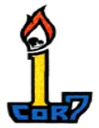
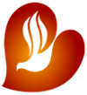
BUKAS LOOB sa DIYOS
(Open in Spirit to God)
Catholic Charismatic Covenant Community
Rochester, NY District

Solo Parents Encounter

Dear brother / sister,

May the peace of the Lord be always with you and your family,
The Bukas Loob sa Diyos (BLD) Rochester Community invites you to a weekend encounter with God. We are sponsoring the Solo Parents Encounter on April 25 – 26, 2026 at St. Patrick’s Church, 15 Maple Avenue, Victor, NY 14564.
The weekend encounter offers you a fresh outlook on your role as a widowed, separated, divorced, single parent, or single caregiver and invites you to the love of our Lord Jesus Christ who calls you to Himself. Be refreshed and restored in faith through the Holy Spirit who gives you strength to journey through life with others. This weekend, experience the healing grace and faithful love of the Lord.
“For surely I know the plans I have for you,” says the LORD,
“plans for your welfare and not for harm,
to give you a future with hope.” (Jeremiah 29:11)

To complete your registration, submit your Personal Information Sheet, with your check in the amount of $50.00. Make the check payable to Rufina Mascioletti. Mail your form and check to
753 Hard Road, Webster, NY 14580 on or before March 28, 2026.

If you have any questions, please contact Jeanne Walker at (315) 576-0103, jeannewalker32@gmail.com.

See you at the weekend encounter!

Yours in Christ,

(BLD) Bukas Loob sa Diyos
Rochester Community

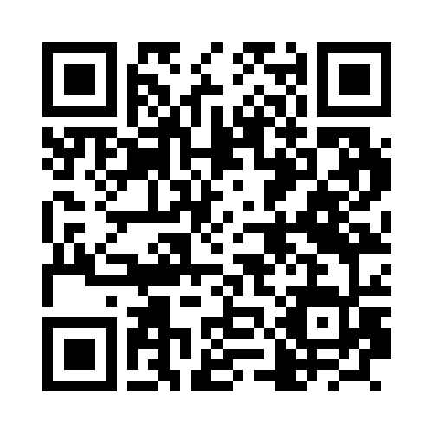
Scan the QR Code with your smart phone and it will take you to the flyer and registration form.

